|  |
| --- |
| Mercer University |
| Project 3 |
| SSE 656 - Object Oriented Project Methods |
|  |
| **Tanya Do, Grey Newell, and John Robison** |
| **12/5/2014** |

|  |
| --- |
|  |

Contents

Introduction 4

Problem Statement 5

Initial Meeting With the Customer 5

Commonality and Variability Analysis 6

Features and Requirements 7

Domain Analysis 9

Use Cases and Use Case Diagrams 9

Problem Submission Use Case 10

Problem Judging Use Case 10

Creating a Competition Use Case 11

Use Case Diagram 11

Technologies Used 12

Architectural Analysis 15

The Three Q's of Architecture 15

Risk Analysis and Reduction 15

Additional Discussion with the Customer 15

Test Cases Used 15

Development of the System 15

Development of the Admin Portal Feature 16

Development of the Problem Submission Use Case 16

Development of the Problem Judging Use Case 16

Test Results and Quality Analysis 16

Conclusion 16

**Table of Figures**

Figure 1: Use Case Diagram 12

Figure 2: MVC Interaction Diagram 13

Figure 3: A Visual Representation of Loose Coupling 14

Figure 4: A Visual Representation of Strong Coupling 14

**Table of Tables**

# Introduction

Our development team is Trident Developments. Our team members are Tanya Do, Alexander Newell, and John Robision.



In this paper, our development team will provide a problem statement about out the web-based application we created, covering the purpose of the application. We will provide the transcription of interviews we had with our customer, Mercer University’s Computer Science Department, where they provide in detail the requirements of the application and the context in which the application will be used, follow up concerns, and discussion of the progress of development.

Additionally, to maintain transparency between our team and the customer, we discuss our decisions and development process in detail. We have included our commonality and variability analysis. We’ve extracted information from the interview and compiled a features and requirements for the judging application. Domain analysis of the application is covered, as well as use case scenarios.

We choose to use the MVC (Model View Controller) design pattern for this application. And this paper, we discuss what MVC is, and why it was the best match for the application. We will also talk detail our architectural analysis and the three questions that determine architectural significance. We will then delve into coding development, dividing the discussion into parts of the application that were use-case-driven and parts that were feature-driven. And we’ll review our testing methods and the results.

# Problem Statement

Our development team was approached by the Mercer University Computer Science Department (MU CS Dept.), to create a tool to judge their annual programming competition. The MU CS Dept. is trying to expose and encourage more students to the field of computer science and programming. As a result of this initiative, the MU CS Dept. organizes and hosts an annual programming competition aim at college students.

We are building a web-based application that will facilitate the operations of a programming competition. A programming competition will have multiple teams submitting solution to problems, and a team of judges pulling the problems, and grading them.

# Initial Meeting With the Customer

Our development team received an email expressing interest in our services, from Mercer's CS Department. To clarify the requirements and purpose of the project, we scheduled a meeting to discuss the program judging application.



**Trident Developments:** Hello! We're so glad you considered our development team for your project. Could you tell us more about the programming competition you are organizing?

**Mercer CS Department**: Absolutely. We want to encourage more students to study Computer Science. And we thought it would be best to start before they start college. We primarily market our programming competition towards other college students. And we are thinking about expanding the number of participants for the competition. And so what we are using now would not support a larger number of teams participating.

**Tri Dev:** Okay, great. Could you please walk us through how the programming competition works?

**MU CS:** Yes. For the competition we have a set of programming problems that we hand out to the teams. The teams may solve the problem in the language of their choice: C#, python, java, C++, etc. So when they code up the solution to the programming problem, they have to log into the system with their team login. Go to the submission page, choose which language the solution is in, and then upload their solution file.

**Tri Dev:** Meanwhile, what does the Judge do?

**MU CS:** Well after the teams submits their solutions, the Judge is able to see the upload and the accompanying information about it. And then they run the solution on their own computers and compare the output with the correct output. If the solution is correct, the team’s score is posted on to the score board. If not, the Judge will give feedback on the type of error the solution produced. And post to the scoreboard that the number of times the team has attempted the problem so far.

**Tri Dev:** And who sets up the competition, such as start time and team logins?

**MU CS:** We would like an Administer role that does that. The admin should be able to set up the parameters of a competition. Such as how many programming problems there are, what the contest start date and time is, when the contest ends, and how many teams logins are needed. Additionally, they should be able to act as a Judge or a Participant.

**Tri Dev:** Okay, great. Thank you. We’ll get to work.

# Commonality and Variability Analysis

Based on this meeting with the customer, our team began analyzing other similar systems to see how they had approached the problem of providing a Programming Team Judge client to schools and competitions. The analyzed systems are: The judging client used at the Association Computing Machinery (ACM) International Collegiate Programming Competition (ICPC) hosted by Baylor University, the judging client used by the Consortium for Computing Sciences in Colleges (CCSC) Southeast Competition, and the open sourced judge client created by Chip Bell (<https://github.com/chipbell4/Judge>). Each of these systems has strengths and weaknesses that our team used as references in the design of our system.

There were features from each of the examined systems that would be useful in the design of our Judging Client. Other than the common scoreboard that each client had, some of these features were: the ability for teams to ask questions to the judges given by the CCSC client, the neatness of the web interfaces given by Chip Bell's client, and the layout of ACM's scoreboard. Our team really liked the idea of allowing teams to interact with the judges in a way that allowed common problems to be easily clarified. An intuitive and neat interface allows users to interact with the system more efficiently and reduce any unnecessary stress or strain on the users. Our team felt that the advantages of the ACM scoreboard was that it would highlight all correct submissions with special colors (such as gold for the first correct submission) as well as provide the time of the correct submission which would allow users to follow the trends of the competition and enhance strategies. However, since the team/judge interaction was not within the scope of the project given to us by our client they have requested that we wait until the second revision of this application to implement this feature. The other liked features will still be implemented because they do fall within the scope of the project.

While each system had features that were admired, they also had features that our design team did not want to implement in our Judge Client. These features include: The unintuitive and slow design of the CCSC client, and the lack of user interaction with Chip Bell and ACM's clients. While an intuitively designed user interface enhances a user's experience, a slow and unintuitive design will inhibit the user. Our team felt that the CCSC system was confusing to use and would often cause major slowdowns at various stages of the competition. Even though our client would like to wait to add the user/judge interactions, we still felt that the lack of this interaction was a downfall of both Chip Bell and ACM's systems.

# Features and Requirements

After meeting with the customer and performing a commonality and variability analysis on the system, our team derived a list of the features that would define the system as well as the requirements that would compose each of these features. These features are listed below:

* User Accounts
  + Teams
  + Judges
  + Admins
* Creating a Contest
  + Creating Problems
  + Adding Teams
  + Setting the Usable Languages
  + Setting the Start and End Times
* Viewing the Scoreboard
* Submitting a Solution
  + Uploading Source Code
  + Selecting the Used Language
* Judging a Submission
  + Claiming a Submission
  + Downloading the Judging Packet
  + Choosing the Appropriate Result
    - Correct
    - Wrong Output
    - Compile Time Error
    - Runtime Error
    - Presentation Error
* Reviewing Judged Submissions

The User Accounts will be responsible for allowing users to have different experiences with the system based on what their role in the competition is. These accounts will limit each user's operations and responsibilities within the system so that they are not able to overstep their limits. These responsibilities are as follows:

* Team Accounts will be the most common user to the system. They will be responsible for allowing participants to be able to submit solutions to problems and review their judged solutions. The submissions will consist of the user's source code which will be uploaded to the server as well as the programming language that was used in the submission.
* Judge Accounts will be responsible for allowing Team Accounts to have correct (or incorrect) submissions. They will be able to claim a submission and then judge it based on the output from the submitted source code. To allow a Judge the ability to judge submissions, the system will provide the Judge with a judging packet that consists of: the submitted source code, the judging input, and the judging output. Using these files, the judge will be able to run the source code with the judge input and compare this output with the provided judge output. The possible reviews that a Judge can give a submission are: Correct, Wrong Output, Compile Time Error, Runtime Error, and Presentation Error.
* Admin Accounts will be responsible for setting up and managing competitions. They will be able to add users (such as Teams and Judges), problems, and usable languages. The Admin will also be able to create a competition using this information as well as set the start and end times of these competitions.
* All users will be able to view the scoreboard that will show the ranking of the teams based on their number of correct submissions and penalty points accrued.

# Domain Analysis

# Use Cases and Use Case Diagrams

To ensure that our team has a more complete understanding of how the system should work, use cases were derived for the major interactions that users can have with the system. These interactions include:

* Submitting problems
* Judging problems
* Creating contests
* Creating problems
* Creating users

Our design team has determined that there will be three types of users for this system: Admins, Teams, and Judges. A use case of the main path was created for each of these types of users.

An Admin will be the user that sets up the competitions as well as creating user accounts for the Teams and Judges. The Admins will be able to specify all of the aspects of a competition such as: the Problems used in the competition, the Users participating in the competition, and the Languages that the Users will be able to submit their source code in. The Admin will also decide the start and end times of each competition.

Teams will be the main users of the system. They will be the users who are solving and submitting answers to the problems posted by the Admins. They will be able to decide which problem they want to solve and in what language they want from the lists provided by the Admin. After they have submitted their solutions, they will be able to review the judging of their solution and resubmit if necessary.

The final user group is the Judges. The Judges will be responsible for reviewing the Teams' submissions. To review these submissions, they will be proved the submitted source code as well as judging inputs and outputs. The judge will run the source code with the provided inputs and then compare the produced output to the provided output. Based on this comparison, the Judge will select the most appropriate response (i.e. "Correct Solution" or "Wrong Output").

The following subsections contain these use cases as well as the use case diagram that shows all possible interactions that a user can have.

## Problem Submission Use Case

1. The user navigates to the web URL associated with the judge application
2. The user logs in to the judge application with a team's credentials
3. The user views the scoreboard and selects a problem to solve
4. The user clicks the "Team" link
5. The user selects the solved problem from the drop down, selects the language used, and uploads the source file
6. The user waits for the problem to be judged
7. Once the problem is judged, the user returns to the Team page and views the judged problem to see the judge's comments

## Problem Judging Use Case

1. The user navigates to the web URL associated with the judge application
2. The user logs in to the judge application with a judge's credentials
3. The user clicks the "Judge" link
4. The user claims a submitted problem
5. The user downloads the zip file that contains the submitted source code, the input file, and the output file
6. The user runs the source code with the input file as the input to the system
7. The user compares the given output to the generated output
8. Based on this comparison, the user selects a judging option for the claimed problem

## Creating a Competition Use Case

1. The user navigates to the web URL associated with the judge application
2. The user logs in to the judge application with an Admin's credentials
3. The user clicks the "Admin" link
4. The user clicks the "Users" link
5. The user clicks the "New User" button
6. The user enters information for the new team and clicks the "Create" button
7. The user clicks the "Problems" link
8. The user clicks the "New Problem" link
9. The user enters a Problem name and provides the judge input and output and clicks the "Create" button
10. The user clicks the "Languages" button
11. The user clicks the "New Language" button
12. The user enters the language of their choosing and clicks the "Create" button
13. The user clicks the "Contests" link
14. The user clicks the "New Contest" button
15. The user selects the added team and problem, and selects start and end times
16. The user click the "Create" button

## Use Case Diagram

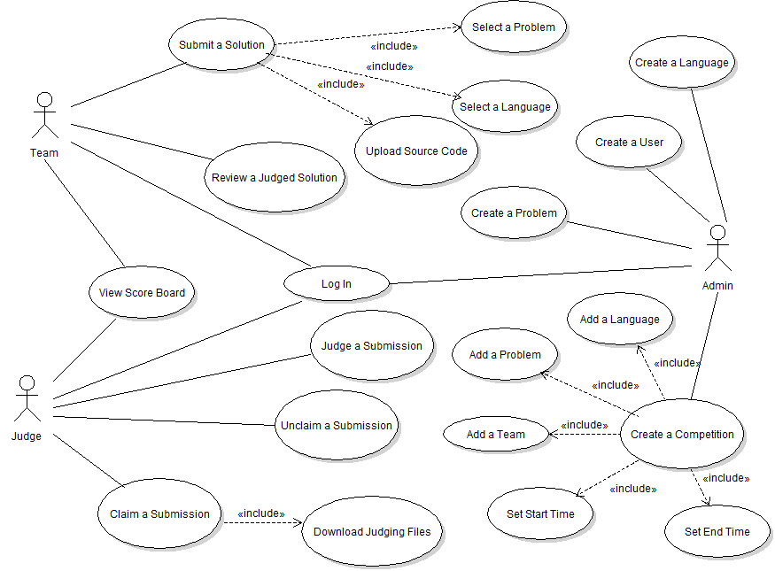

Figure 1: Use Case Diagram

# Technologies Used

This project employed the use of the ASP.NET MVC (Model-View-Controller) framework. The framework streamlines adoption of the MVC design pattern which encourages designs to be loosely coupled through a separation of concerns, and also enforces MVC related standards in our code. This separation is achieved by using the three main components: Models, Views, and Controllers. Models define the schema by which system data is stored and interacted with. Views are responsible for constructing the façade the user interacts with and displaying data from the appropriate Models in a human-readable fashion. Controllers are the “under-the-hood” components which respond to user inputs by updating the models and views accordingly. Below in Figure 2 is a diagram that visualizes the interaction between these components.

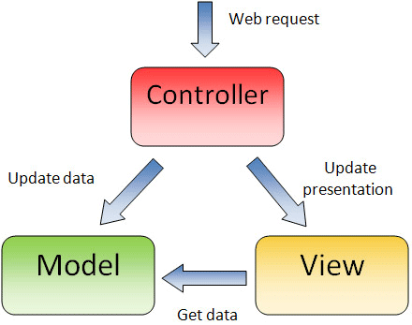

Figure : MVC Interaction Diagram

The ASP.NET framework builds on the MVC design pattern by relying on a "convention over configuration" approach which reduces the amount of code required to implement the design pattern for a project. This approach enforces certain facets of the design pattern, such that items are placed in the correct directories and named according to the MVC Schema; i.e. Controllers must be in the Controller folder and its name will end with "Controller.” Not only does this convention based approach reduce code requirements, it also aids in overall readability of the system.

Due to the loose coupling offered by the MVC design pattern, our team chose ASP.NET MVC as the framework for this system because it allowed for code reuse and distributed development in parallel. Since the models, views, and controllers are separated, they can easily be reused within another application, individually or as a whole. An example of this type of code reuse would be if the customer requested a mobile application. Model and Controller classes could be reused as-is for the backend, and all developers have to do is define new views for the mobile platform. This separation also allows components to be designed and built separately. One developer can build the store user interface in the views while another developer designs the underlying business logic in the models concurrently.

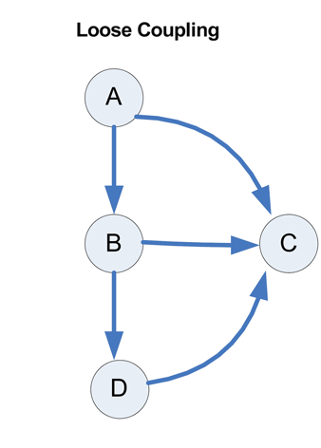

Figure : A Visual Representation of Loose Coupling

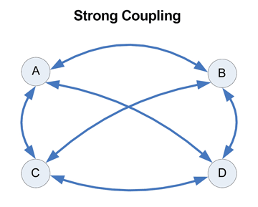

Figure : A Visual Representation of Strong Coupling

In addition to the aforementioned benefits of MVC's separation of concerns listed above, our team decided to develop with the ASP.NET MVC Framework for its use of .NET languages (in particular C# and Visual Basic) which we are already familiar with, and due to the success of our previous project employing this framework. In addition, the Razor view engine was easy to work with and teach to our newest developer, who actually became proficient with the engine quickly enough to implement most of our Views. C#, our .NET language of choice, is extremely powerful and easy to develop with due to its number of available libraries and the use of Microsoft Visual Studio’s Intellisense utility. Intellisense can auto-fill code for the developer such as variable and method names, whether the variable is a member of a project or one of its associated dependencies. The Razor view engine is a combination of HTML and either C# or Visual Basic, which makes it very natural for .NET developers to write and learn. The use of C# in the markup allows for very powerful dynamic web pages. Razor also allows the use of layouts which enables developers to have a single Razor file act as a template for all other views. These layouts reduce duplicate code by encapsulating common view elements into the layout. The final advantage of Razor that will aid in development is the ability to use Intellisense to quickly write the markup and code contained in the Razor files.

# Architectural Analysis

## The Three Q's of Architecture

## Risk Analysis and Reduction

# Additional Discussion with the Customer

# Test Cases Used

# Development of the System

Along with the Test Driven Development methodology that our team implemented, we also used Feature Driven Development. While Test Driven Development deals with ensuring that the behavior of a system is as expected, Feature Driven Development deals with deciding logical sections to code a solution to the given problem. Feature Driven Development is the process of working on a specific piece of functionality one at a time. Feature Driven Development is most useful in systems that have many disconnected features or features that don't interact much. One advantage of this approach is that it allows developers to have working features very quickly which can be shown to customers as proof of work completed. Another advantage is that this approach ensures that all features are accounted for and are fully fleshed out. Feature Driven Development was used in the design of the Admin Portal, discussed in the following subsection.

Another development methodology we employed in bringing this project to successful completion is Use Case Driven Development. This process means selecting your features and components to develop according to a certain scenario from a use case. When a Use Case Driven development cycle is over, all features necessary to perform every scenario within a certain use case should be implemented (as much as necessary) and tested. Tackling development with this strategy is a more user-centric and less granular approach as compared to feature driven development, and is considered a “big-picture” approach by the authors of *HeadFirst OOA&D*. Developers often utilize this approach when the system has many scenarios and processes that comprise a single, cohesive user experience. The Problem Submission and Problem Judging portions of our system were developed in this manner.

## Development of the Admin Portal Feature

## Development of the Problem Submission Use Case

## Development of the Problem Judging Use Case

# Test Results and Quality Analysis

# Conclusion